Lab Objective

In this exercise, learn how to configure NPS to support VPN connections

**Lab Procedures**

**1.** On RWDC01, using the Network Policy Server console, click NPS (Local).

**2.** Use the down arrow under Standard Configuration in the main panel, and select *RADIUS server for Dial-Up or VPN Connections*.

**3.** Click Configure VPN or Dial-Up. The Configure VPN or Dial-Up Wizard opens.

**4.** On the Select Dial-up or Virtual Private Network Connections Type page, select *Virtual Private Network (VPN) Connections*. Click Next.

**5.** On the Specify Dial-Up or VPN Server page (as shown in Figure 12-2), click Add.

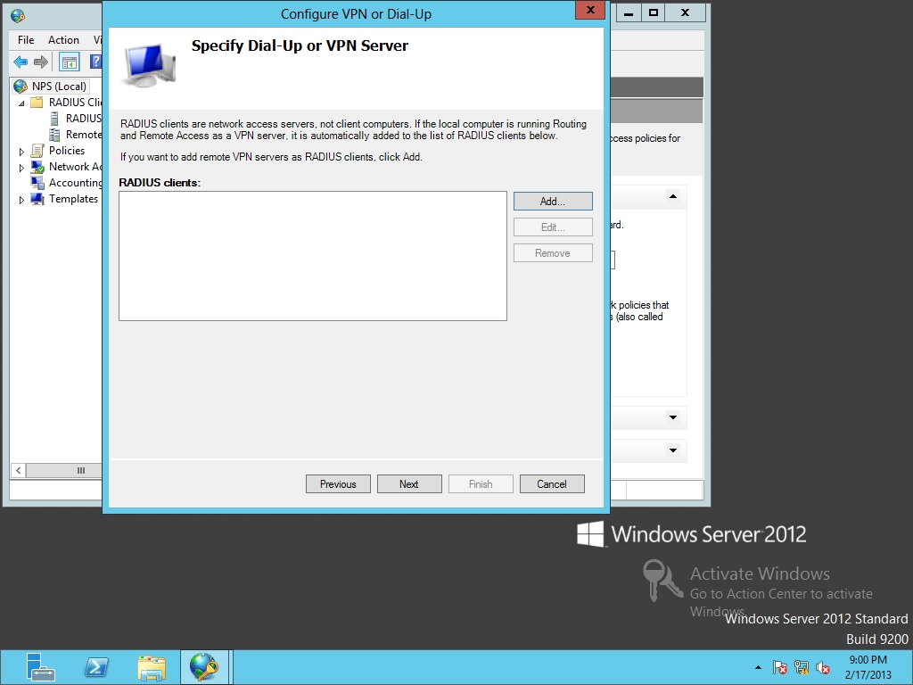

Figure 12-2

Adding RADIUS clients (VPN server)

**6.** When the New RADIUS Client dialog box opens (as shown in Figure 12-3), type **Server01** in the Friendly name text box. In the Address (IP or DNS) text box, type **192.168.1.60**.

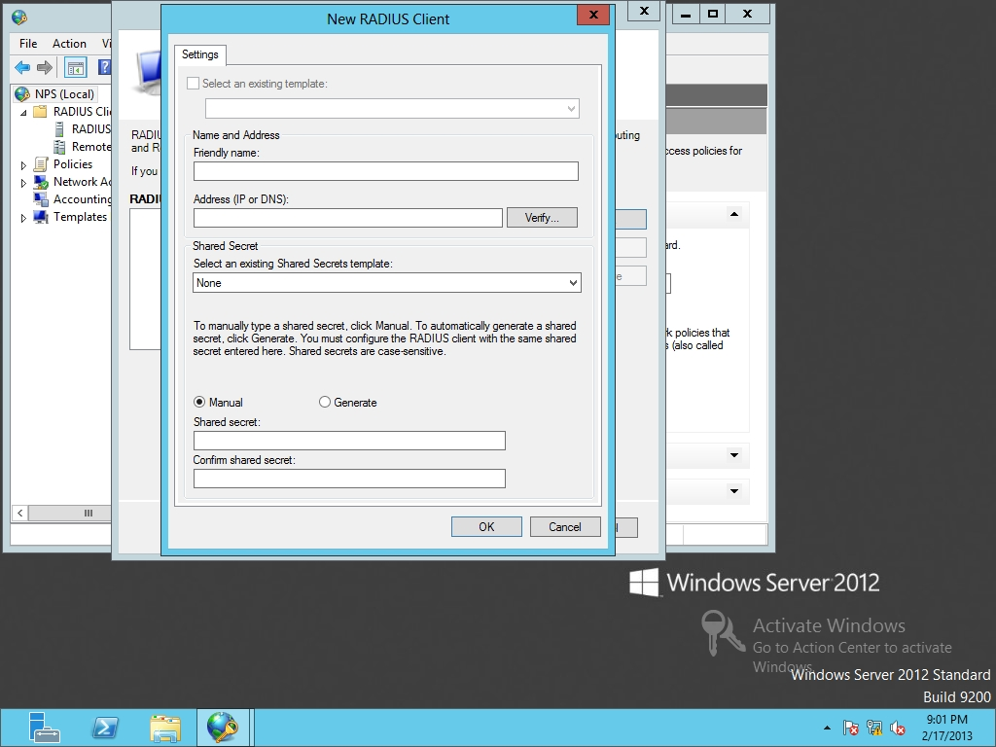

Figure 12-3

Configuring the new RADIUS client

**7.** At the bottom of the dialog box, type **Password01** in the Shared secret and Confirm shared secret text box. Click OK to close the Remote Access Properties dialog box.

**8.** Back on the Specify Dial-Up or VPN Server page, click Next.

**9.** Take a screen shot of the Configure Authentication Methods by pressing Alt+Prt Scr and then paste it into your Lab12_worksheet file in the page provided by pressing Ctrl+V (*Figure 1*).

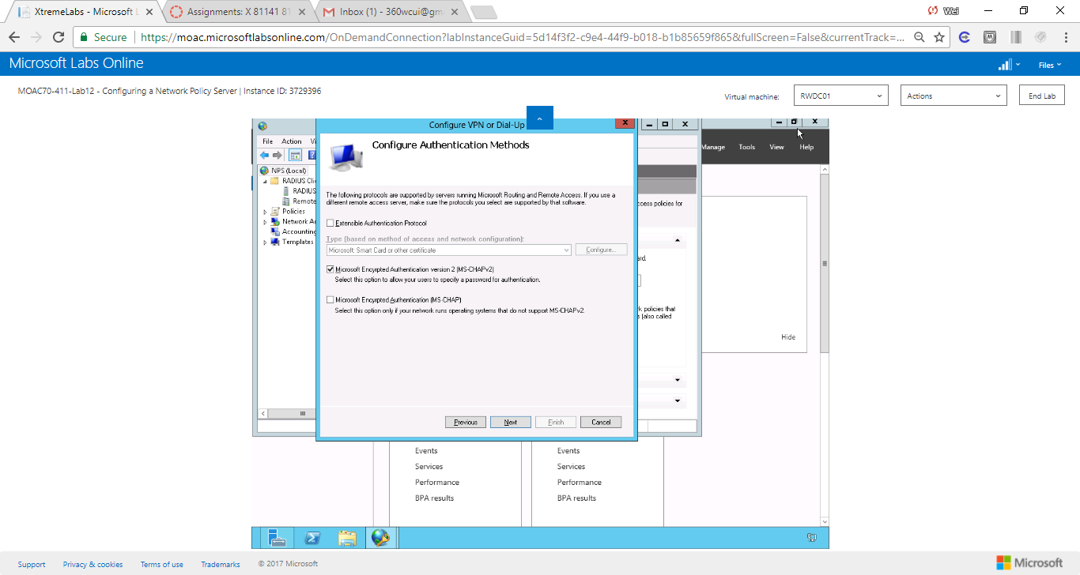

Figure 1 Screenshot of Configure Authentication Methods - Microsoft Encrypted Authentication version 2 (MS-CHAPv2) is selected.

**10.** Click Next.

**11.** On the Specify User Groups page, answer the following question, and click Next.

|  |  |
| --- | --- |
| Question 4 | What happens if you do not define a user group?  If I do not define a user group, the policy applies to all users. |

**12.** On the Specify IP Filters page, click Next.

**13.** On the Specify Encryption Settings page, click Next.

**14.** On the Specify a Realm Name page, type **contoso.com** in the Realm name. Click Next.

**15.** When the wizard is complete, click Finish.

**16.** Under the Policies node, click the Connection Request Policies node and take a screen shot of the Network Policy Server window by pressing Alt+Prt Scr and then paste it into your Lab12_worksheet file in the page provided by pressing Ctrl+V (*Figure 2*).

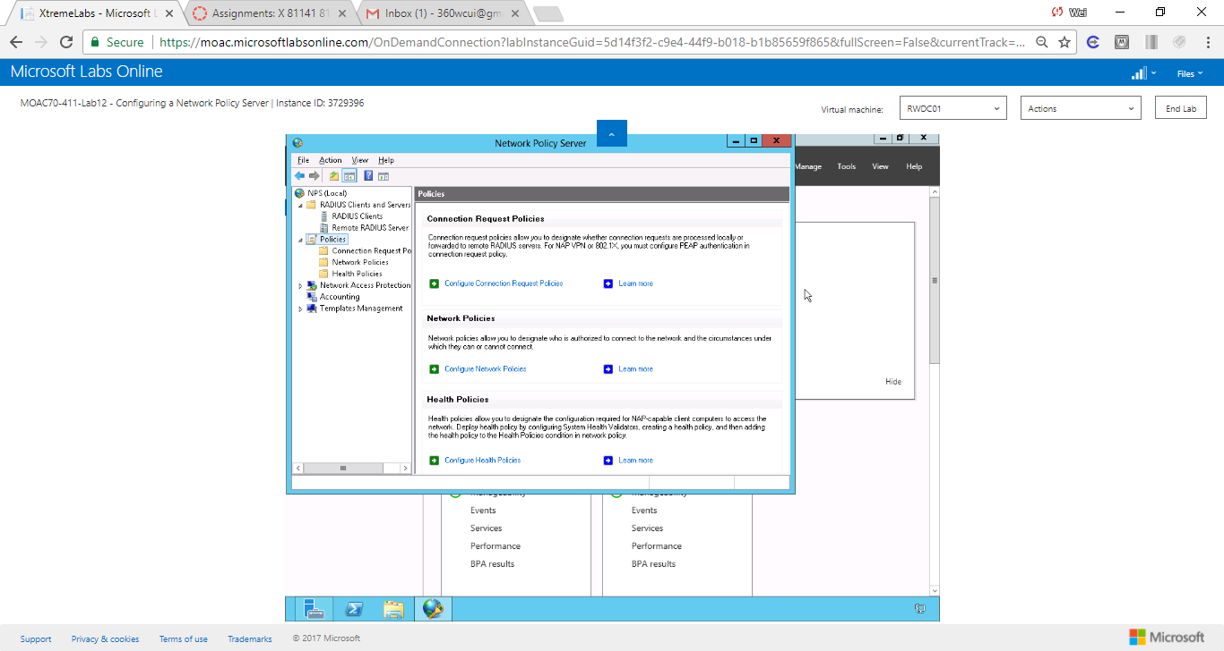

Figure 2 The screenshot shows Connection Request Policies node under the Policies node.

**17.** Leave the Network Policy Server console open for the next exercise.

**Lab Summary**

During this exercise, I learned how to configure Network Policy Server (NPS) to support VPN connections. RADIUS clients are servers and devices (such as wireless access points and 802.1X switch) that forward RADIUS requests to a RADIUS server. An access client is a computer or device that contacts or connects to a RADIUS client, which requires authentication and authorization to connect. From the point-of-view of the NPS server, VPN server or wireless access point is a type of network connection. When a user, using his or her laptop, connects to a VPN server, the laptop considered an object when discussing RADIUS.